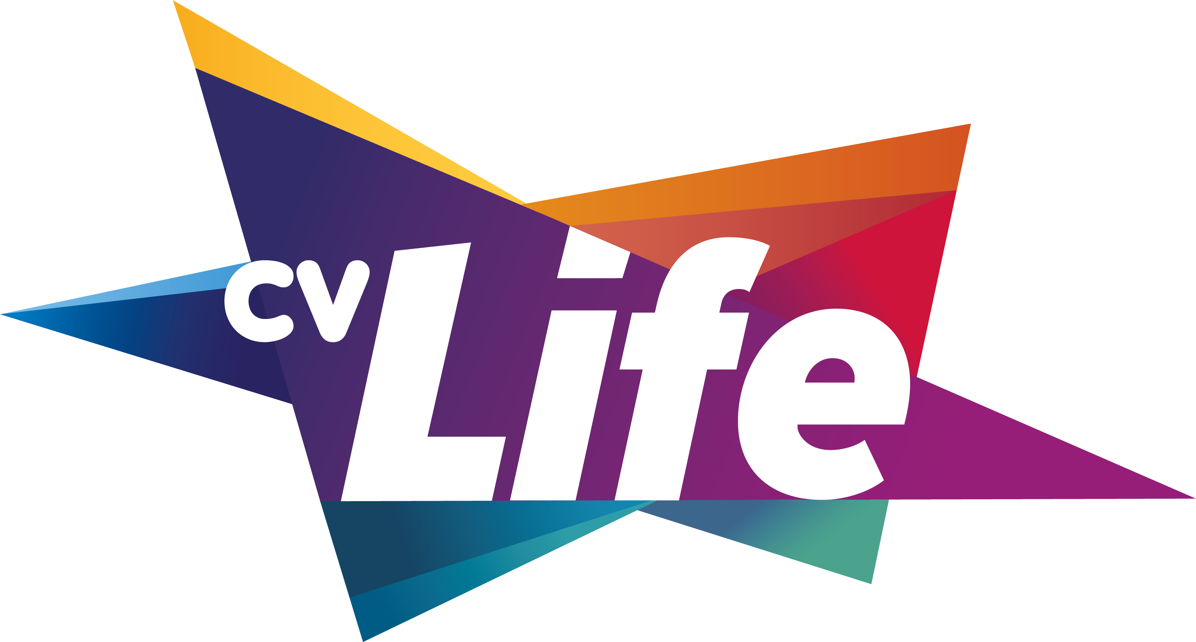
SQUASH LEAGUE
DECLARATION OF INTEREST

Are you interested in joining a Squash League?
Our new Squash League at The Wave is coming, so prepare your racquets for some competitive fun!
To Register your interest, please fill out the form below and return to Wave Reception in-centre or email at wavereception@cvlive.co.uk

CONTACT DETAILS

Name:
Contact Number:

Email:

The information provided on this form will be treated with the strictest confidence and will be destroyed in accordance with the company’s Privacy Notice which can be viewed at www.cvlife.co.uk.

